**SODA VENDING MACHINE**

**By Prathibha**

**Implementation method:**

I have developed the soda vending machine application using Spring Boot, Rest webservices, thymeleaf and h2 database.

1. **Design Considerations:**

**Technical Considerations:**

Application: Spring Boot

Technology: Java8, Rest web services

Database: h2 (It can be used without any external database.)

UI: Thymeleaf

1. **Technical Architecture Design:**

* The project name is “sodaVendingMachine”. The Java code is in “src/main/java” folder.
* The main class DemoApplication.java is in “com.hca.poc” package. It starts the application using embedded Tomcat server.
* The controller is having the rest endpoints that are supported by this application and controller class will use respective service classes to complete the business logic.
* The Service layer and repository layer will act together to execute business logic and will take user to the respective UI based on response.
* The UI is developed using thymeleaf and HTML are present in “src/main/resources/templates” folder.
* The Application properties to use h2 database and to define application port are provided in application.properties file.
* The data with which application tables will get populated is provided in “data.sql”.

1. **Method to use the developed system :**

**Operating steps:**

1. Run the Application. The application will start in 9963 port as given in application.properties file.
2. Use below link to access main page of the application.

<http://localhost:9963/vending/home>

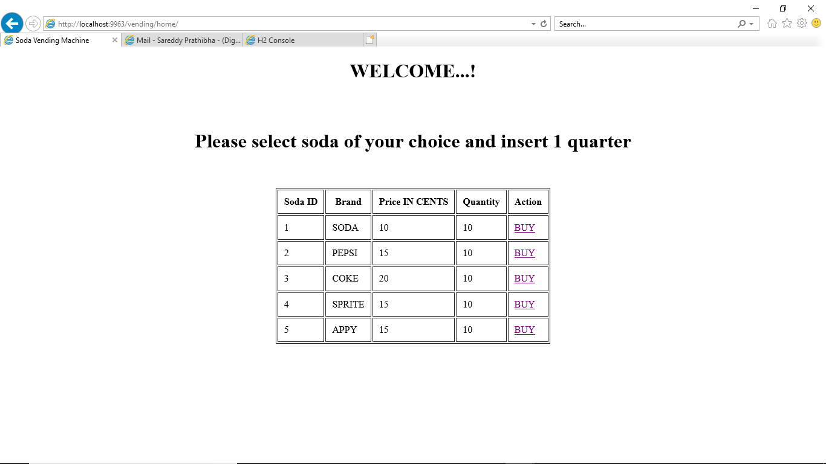

The database table’s status will be

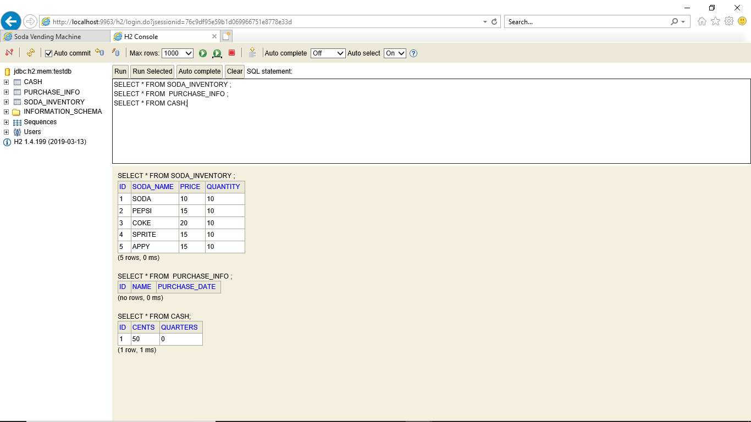

1. User can click on ‘BUY’ link associated with the respective soda type to buy and insert a quarter.
2. The application will validate if the soda is available and the balance change is available. If everything is fine, the quantity will be decreased. The amount in cents will be decreased accordingly and no.of quarters will get incremented.
3. If everything is successful, the purchase information will be saved to database.
4. The success screen will be shown.

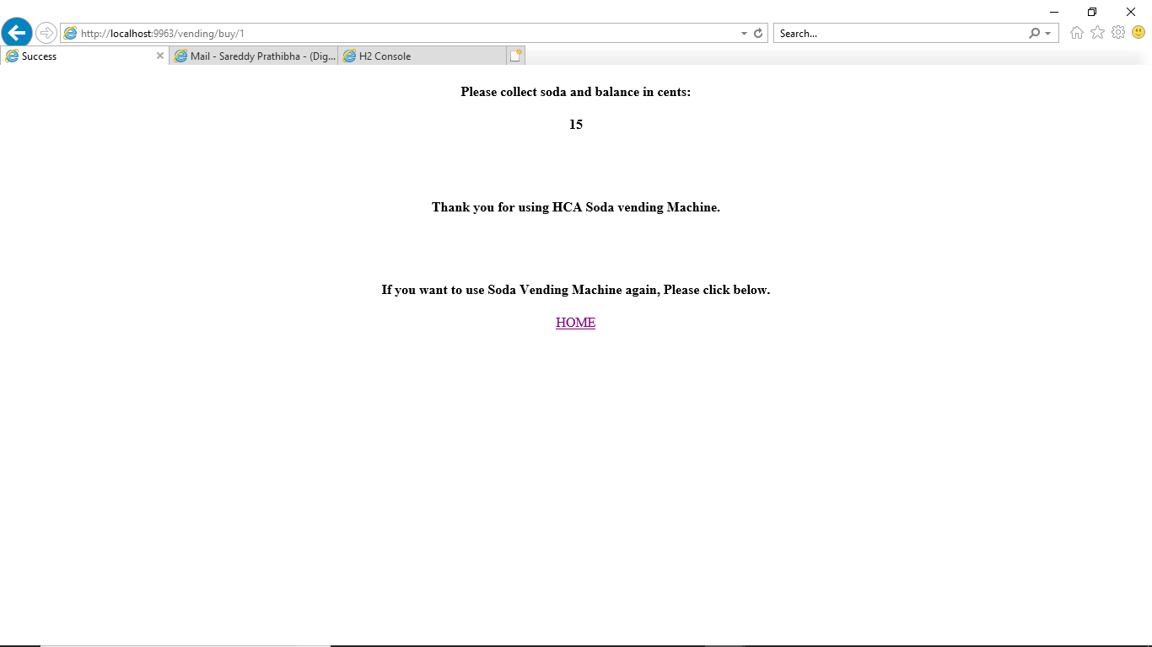

If Soda is not available, the below screen is shown.

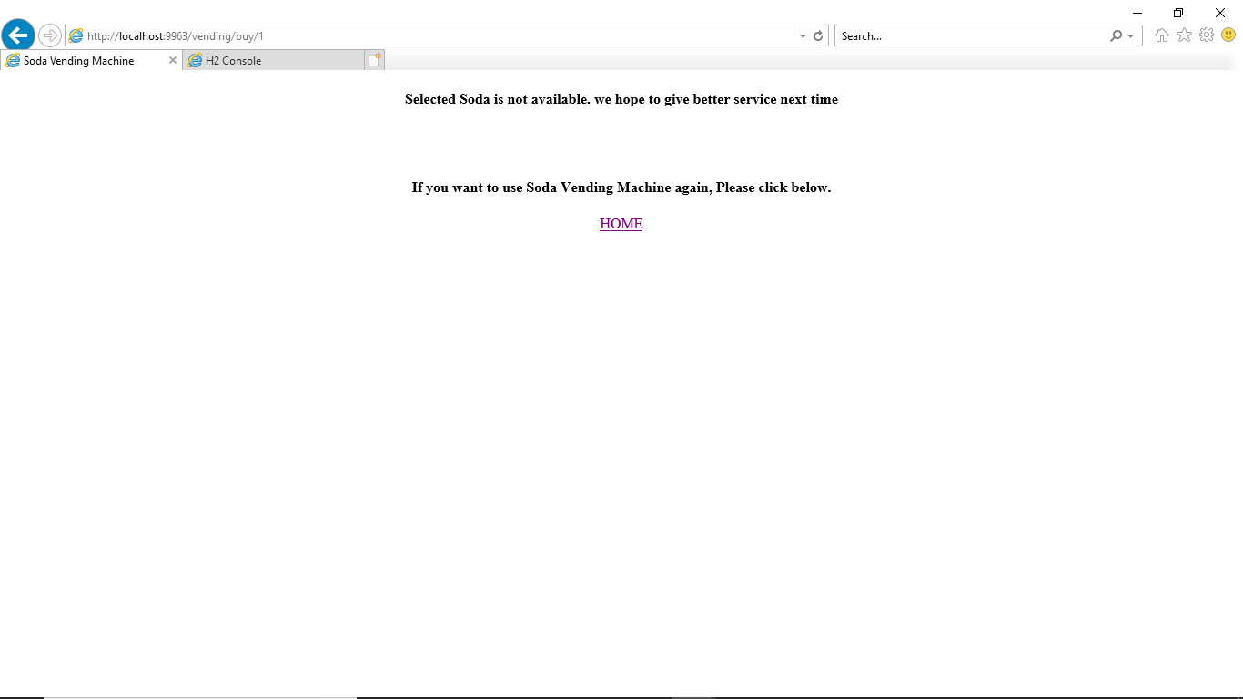

If change is not available, below screen will be shown

